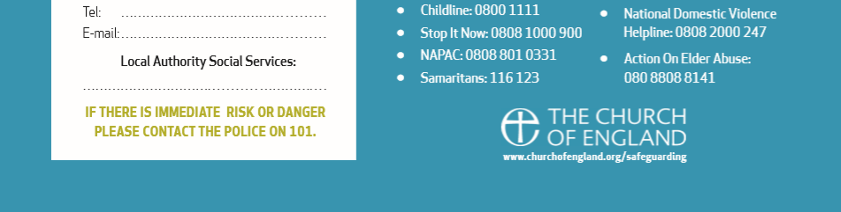
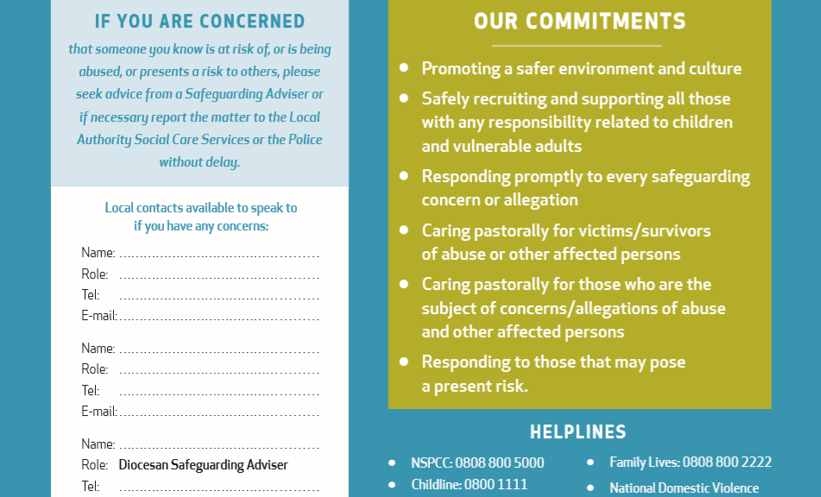
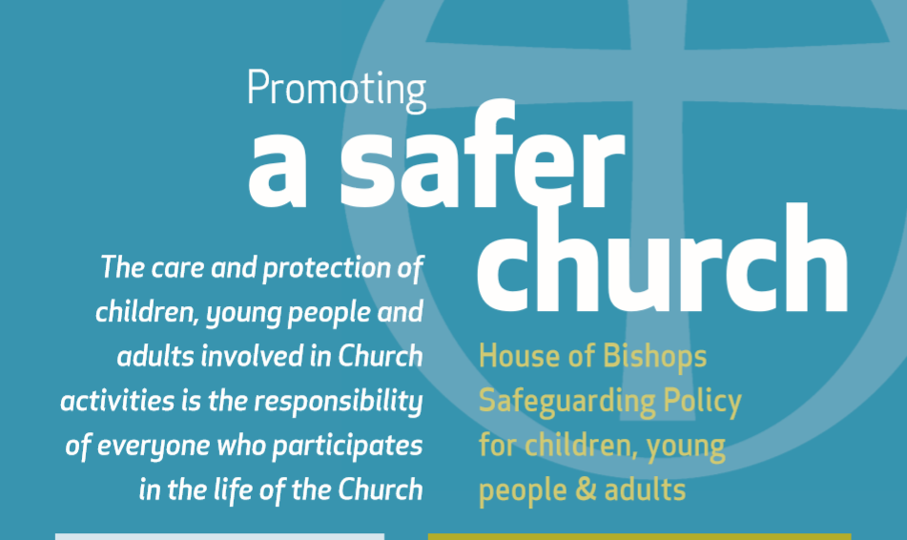
Mrs Joyce Wild, Parish Safeguarding Officer
Tel: 01484 535204

Revd. Ian Jamieson, Priest-in-Charge
Tel: 01484 427838
Email: revianjamieson@gmail.com
Diocesan Safeguarding Advisors
Jenny Leccarde – 07872 005 189
Narinder Lyon – 07873 005 309

Kirklees Local Authority Social Services:
Re: Children: 01484 456848
Re: Adults: 01484 221000
(Out of office hours for both: 01484 414933)
IF THERE IS IMMEDIATE RISK OR DANGER PLEASE CONTAXT THE POLICE ON 101

